***Computer Science***

|  |  |
| --- | --- |
| **Project Name** | **Revamp of High Energy Physics Laboratory’s Computer Systems** |
| Team Lead: | Ryan Wojtyla |
| Team Member(s): | Josef Bostik, Eric Periera |
| Faculty Advisor(s): | Dr. Marcus Hohlmann, Dept. of Aerospace, Physics and Space Sciences, Florida Institute of Technology |

Dr. Hohlmann's High Energy Physics (HEP) research group at Florida Tech contributes to micropattern gas detector research for both the Compact Muon Solenoid (CMS) experiment at CERN and the future Electron-Ion Collider (EIC). In order to conduct this research, the group makes extensive use of several computer systems. These systems can be split into three main sections: the high throughput computing cluster, the muon tomography station (MTS), and general use machines.

The high throughput computing cluster is primarily used by the group's researchers to store data and run calculations. It is also affiliated with the Open Science Grid (OSG), where researchers from across the globe can submit jobs to be run. The MTS is an experimental device that makes use of micropattern gas detectors to track the paths of muons in order to image an object placed within it. Our project focuses on the computer system used to interface with the device. The research group uses general purpose Linux machines to interface with miscellaneous detectors and electronics, process and store data, and run simulations. The researchers using these machines often run into technical trouble and benefit from technical assistance provided both within and without the group.

The computing cluster had been under severe maintenance for a good deal of time, and its software would soon be outdated. After communicating with them for some time, the OSG support staff recommended a full rebuild of the entire system. The computer system for the MTS was running outdated software, had grown unreliable, and had an inefficient and convoluted data-taking workflow. The lab’s general purpose machines, while largely usable, had much room for optimization in terms of resource allocation and workflow automation.

**Linux Computing Cluster General Purpose Machines Muon Tomography Station**

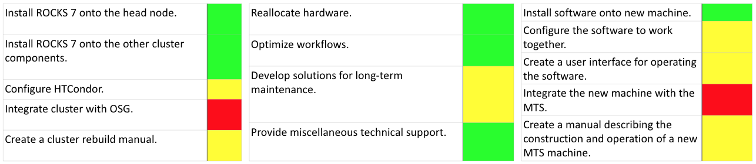

We had substantial difficulty installing the latest version of the cluster-building Rocks Linux distribution on first the head node, then the subsequent cluster components. While building and configuring the software for the MTS's new computer system, we found that the installation procedure requires very specific versions and configurations of all the pieces of software. Although the servicing of the general computer systems was not without hiccup, it was far less catastrophically burdensome than the other two sections of computing.

**Daniel Campos** helped us overcome obstacles encountered with the computing cluster. **James Cicak** from Florida Tech’s IT department helped start us off with the computing cluster. MTS researchers, **Miguel Gutierrez** and **Tommy Walker**, provided us with guidance in designing the new MTS machine. **Samantha Wohlstadter** assisted us a great deal with the computing cluster, saving us much valuable time.